You want to **build a CI/CD pipeline** in Azure DevOps that:

1. Clones a GitHub or Azure Repos repository.

2. Installs dependencies.

3. Runs a Python data processing script.

4. Publishes the processed output as an artifact for later use. **Project Structure**

azure-data-pipeline/

├── data_pipeline/

│ ├── fetch_data.py

│ ├── process_data.py

│ └── requirements.txt

└── azure-pipelines.yml

**Step 1: Sample Python Scripts**

**fetch_data.py**

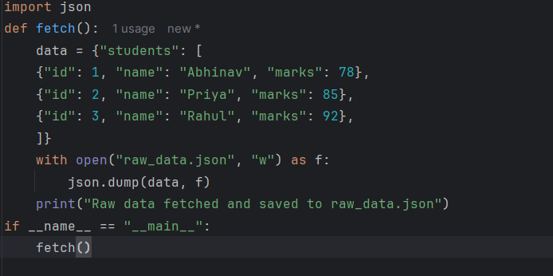

**process_data.py** 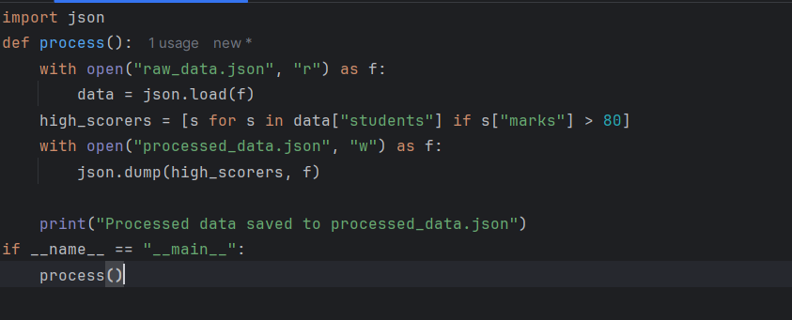

**requirements.txt**

pandas

**Step 2: Azure Pipelines YAML ( azure-pipelines.yml )**

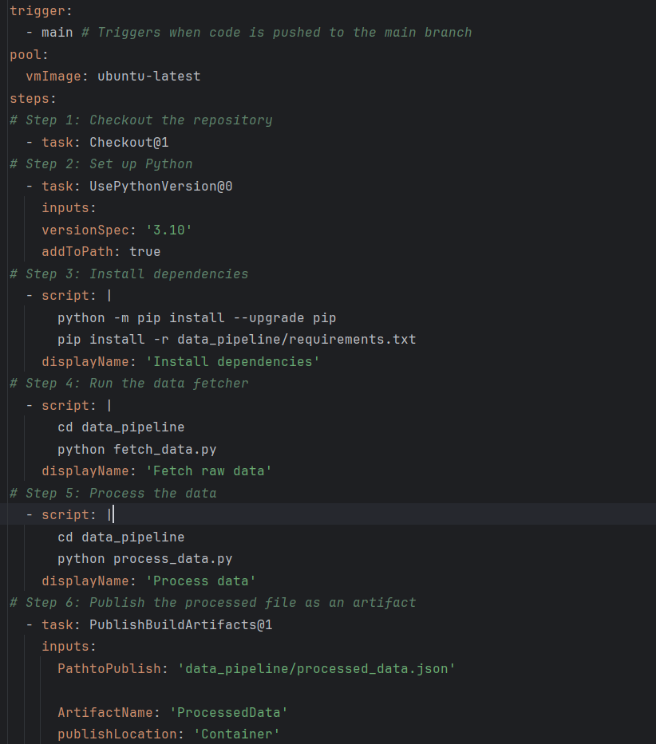

**Step 3: How to Run**

1. Go to **Azure DevOps Portal → Pipelines**.

2. Click **New Pipeline** → Connect your repo → Select **YAML**. 3. Point it to azure-pipelines.yml .

4. Save & Run.